Report: Implementing a Dynamic Product Listing Component
Mehdi Abbas - 461734
Objective:
The primary objective of Day 4 is to design and develop dynamic frontend components that can display marketplace data fetched from Sanity CMS or external APIs. This process focuses on modularity, reusability, and applying real-world development practices to build scalable and responsive web applications.

Task Overview
Objective:
Build a Product Listing Component for a marketplace.
Requirements:
- Fetch product data dynamically using Sanity CMS or an external API.
- Display the data in a grid layout of cards with the following details:
- Product
- Name
- Price
- Image
- Stock
- Ensure responsiveness across devices.
- Implement modularity by breaking the component into smaller, reusable parts.
Tools & Technologies:
- Framework: React or Next.js
- CMS: Sanity CMS
- Styling: Tailwind CSS or plain CSS
- State Management: React Hooks

Implementation Plan
- Set Up Data Fetching:
  - Integrate Sanity CMS or API endpoints to fetch the product data dynamically.
  - Use React hooks (_{useEffect}) for data fetching and (_{useState}) to store and manage the data.
- Design Reusable Components:
  - Break down the Product Listing Component into smaller parts:
  - Product Card Component: Displays individual product details.
- Apply Responsive Design:
  - Use Tailwind CSS or CSS Grid/Flexbox to ensure the grid layout adapts to all screen sizes.
- Enhance User Experience:
  - Highlight important details like stock status with conditional formatting. o Add hover effects for better interactivity.
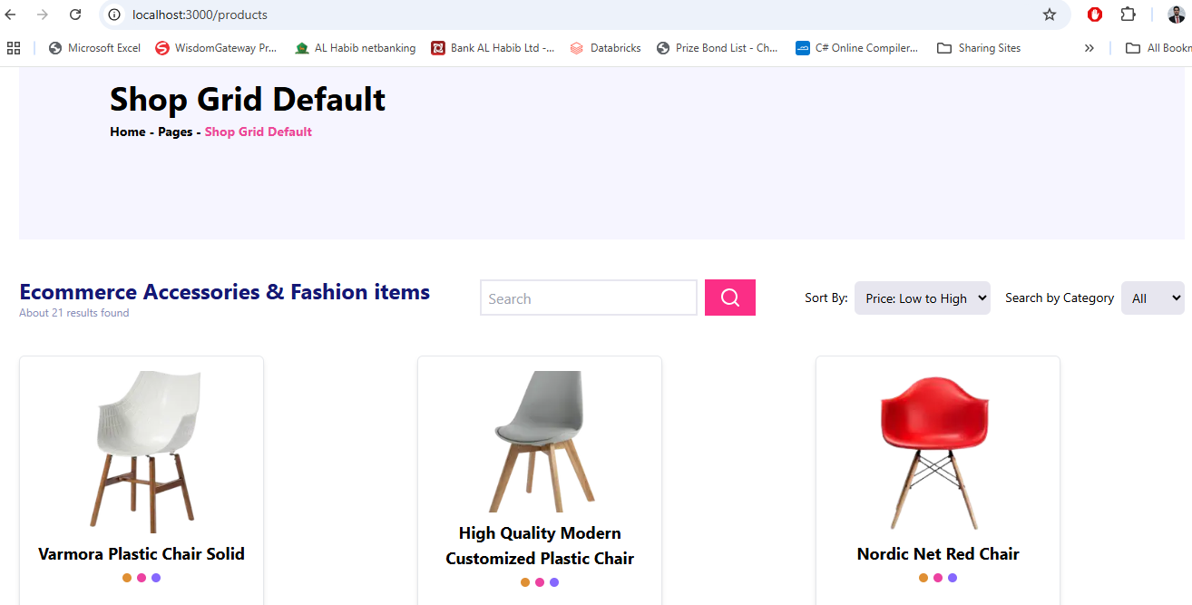

Product Detail Component
Objective:
Develop individual product detail pages using dynamic routing in Next.js. These pages will display detailed information about each product, including:
- Name
- Product Description
- Price
- Category
- Stock Availability Implementation Plan:
- Dynamic Routing:
  - Create dynamic routes using the [id].tsx file in the pages/products directory.
  - Fetch product data based on the product ID from a CMS like Sanity or an API.
- Data Fields:
Each product detail page should include the following fields:
  - Product Description: A detailed explanation of the product, fetched from the backend.
  - Price: Displayed prominently for clear visibility.
- Integration with Product Listing:
  - Link each product card in the Product Listing Component to its corresponding detail page using the Link component in Next.js.
- Styling and Layout:
  - Use Tailwind CSS or plain CSS for a clean and responsive design. o Ensure the layout highlights the product description and price for user clarity.

UI Display OF Product Detail Page:
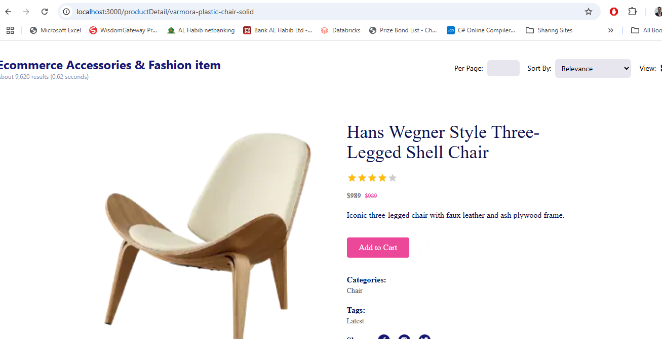

Step 3: Search Bar with Price Filter
Objective:
To implement a search bar and price filters to enhance the product browsing experience.
Implementation Plan:
- Search Bar Functionality:
  - Filter products based on their name or associated tags. o Update the product list in real-time as the user types.
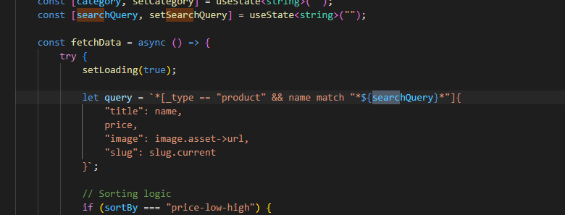

UI Display :
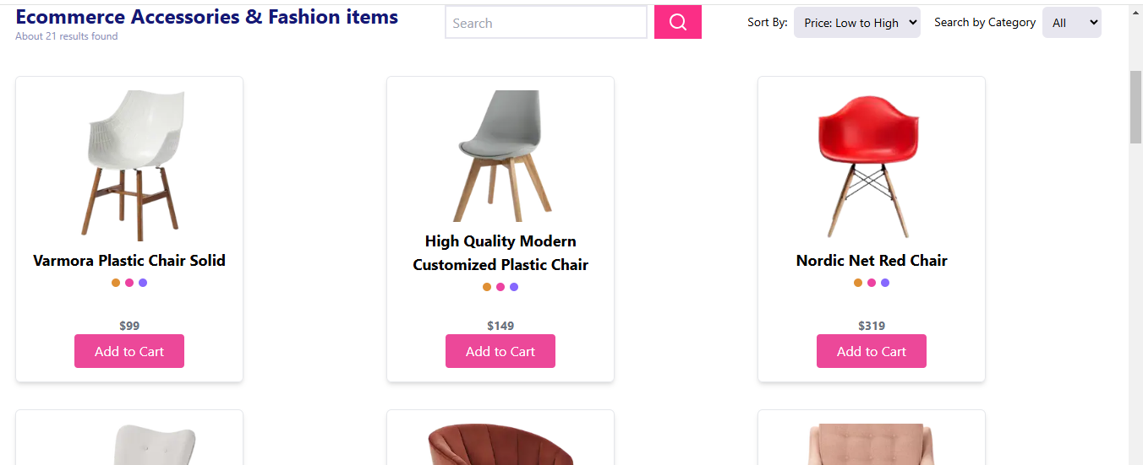

- Price Filtering:
  - Add options to sort products by price in ascending or descending order.
  - Combine the price filter with the search bar and category filter for seamless interaction

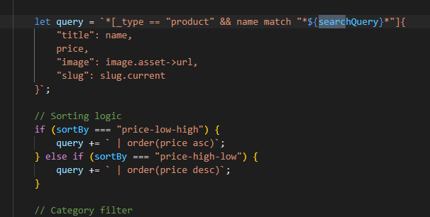

UI Display:

- High To Low:

- Low To High:


Features Implemented:
- Search Bar: o Filters products by name or tags in real time.
- Price Filter:
o Allows sorting products by price (low to high or high to low).

Step 4: Cart Component
Objective:
To create a Cart Component that displays the items added to the cart, their quantity, and the total price of the cart dynamically.

Implementation Plan:
- Local Storage: o Use local Storage to store cart data.
- Cart Data: o Include details for each product in the cart:
    - Product Name
    - Price
    - Quantity
  - Calculate and display the total price dynamically based on the items in the cart.

- Cart Interactions:
  - Allow users to increase or decrease the quantity of items.
  - Automatically update the total price when the quantity changes.
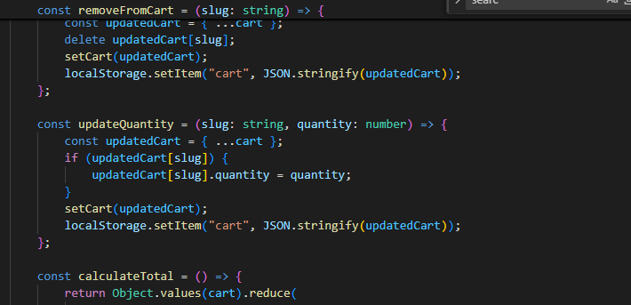

UI Display Of Cart Page:

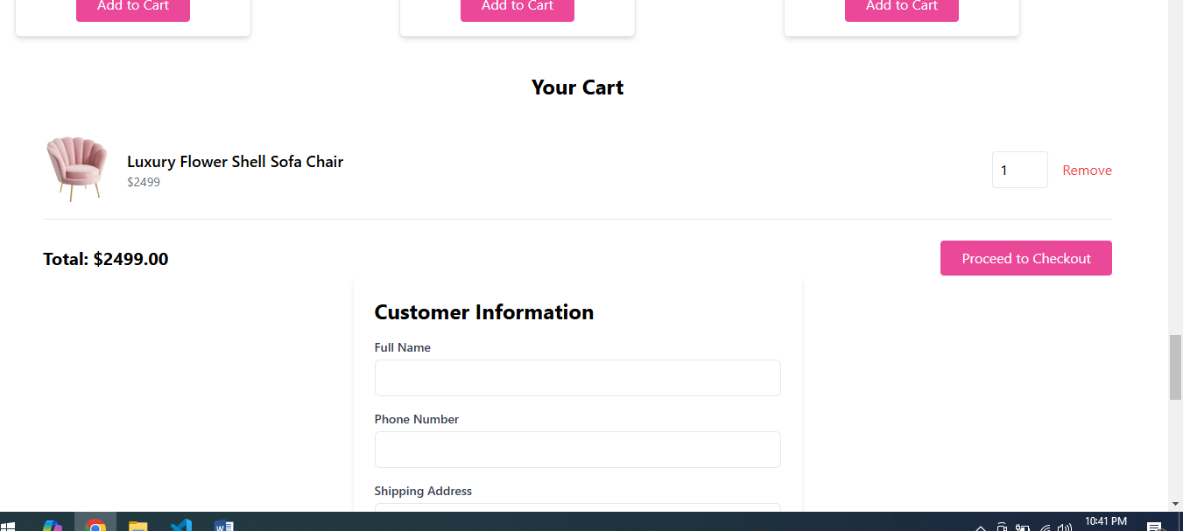
- Dynamic Item Display: o Each item in the cart is displayed with its name, price, and quantity.
  - Subtotal for each item is dynamically calculated.
- Quantity Update: o Buttons to increase (+) or decrease (-) the quantity of an item.
  - Quantity cannot go below 1.
- Total Price Calculation:
  - The total price updates dynamically as items are added or quantities are changed.
- Remove Item: o Users can remove individual items from the cart.

Conclusion
On Day 4 of building dynamic frontend components for a marketplace, the focus was on creating modular, reusable, and responsive components. The following key components were successfully implemented:
- Product Listing Component:
  - Dynamically displayed products in a grid layout with details such as product name, price, image, and stock status.
- Product Detail Component:
  - Built individual product pages using dynamic routing in Next.js, including fields like product description, price, and image.
- Search Bar and Filters:
  - Implemented functionality to filter products by name or tags and added price filters (high to low and low to high).
- Cart Component:
  - Displayed items added to the cart, quantity management, and total price calculation with dynamic updates.

